**CE101 Engineering Drawing July- Nov 2019**

**Indian Institute of Technology Guwahati**

**Lab Sheet-9 Development of Surfaces Wednesday Afternoon**

**Full Marks: 100 Date:23.10.2019**

1. Draw the development of the complete surface of a frustum of cone having base and top diameter of 60 mm and 20 mm respectively with 50 mm height along with FV &TV. (15 Marks)
2. Draw the development of lateral surfaces of a square prism, base 40 mm, and whose adjacent sides are cut by a circular hole at a position as shown in Figure.

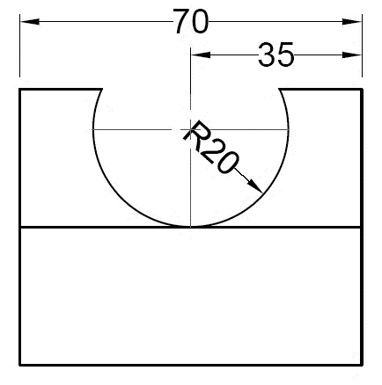 (35 Marks)

1. A sector having included angle of 135° and radius 60 mm is folded into a cone resting on the HP. A thread is wound around the curve surface of the cone starting from the point on the base nearest to the observer. The thread after taking a turn around the cone returns to the initial point. Find out the minimum possible length of the thread and show its projection on FV and TV. (50 Marks)